Experiment 5
AIM: Develop Academic Calendar & Leave Management System using Rich Controls, Session & Cookies.
Source: Login.aspx.cs
Code:
using System;
using System.Collections.Generic;
using System.Linq;
using System.Web;
using System.Web.UI;
using System.Web.UI.WebControls;

namespace Practical_5
{
public partial class Login : System.Web.UI.Page
{
protected void Page_Load(object sender, EventArgs e)
{
if (!IsPostBack)
{
if (Request.Cookies["username"] != null)
{
Username.Text = Request.Cookies["username"].Value;
Remember.Checked = true;
}
}
}

protected void Button1_Click(object sender, EventArgs e)
{
String username = Username.Text;
String password = Password.Text;
if (username == "Student" && password == "123456")
{
Session["Username"] = Username.Text;
if (Remember.Checked)
{
HttpCookie userCookie = new HttpCookie("username", Username.Text);
userCookie.Expires = DateTime.Now.AddDays(7);
Response.Cookies.Add(userCookie);
}
else
{
if (Request.Cookies["username"] != null)
{
HttpCookie userCookie = new HttpCookie("username");
userCookie.Expires = DateTime.Now.AddDays(-1);
Response.Cookies.Add(userCookie);
}
}
Response.Redirect("Default.aspx");

}
}
}
}

Source: login.aspx

Code:

<%@ Page Language="C#" AutoEventWireup="true" CodeBehind="Login.aspx.cs" Inherits="Practical_5.Login" %>

<!DOCTYPE html>

<html xmlns="http://www.w3.org/1999/xhtml">
<head runat="server">
<title></title>
</head>
<body>
<form id="form1" runat="server">
<h3>Login</h3>
<table>
<tr>
<td><asp:Label ID="Label1" runat="server" Text="Label">Username</asp:Label></td>
<td><asp:TextBox ID="Username" runat="server"></asp:TextBox></td>
</tr>
<tr>
<td><asp:Label ID="Label2" runat="server" Text="Label">Password</asp:Label></td>
<td><asp:TextBox ID="Password" runat="server"></asp:TextBox></td>
</tr>
<tr>
<td></td>
<td><asp:CheckBox ID="Remember" runat="server" />Remember</td>
</tr>
<tr>
<td colspan="2"><asp:Button ID="Button1" runat="server" Text="Login" OnClick="Button1_Click" /></td>
</tr>
</table>
</form>
</body>
</html>

Source: Leave.aspx.cs

Code:

using System;
using System.Collections.Generic;
using System.Linq;
using System.Web;
using System.Web.UI;
using System.Web.UI.WebControls;

namespace Practical_5
{
public partial class Leave : System.Web.UI.Page
{
protected void Page_Load(object sender, EventArgs e)
{
if (!IsPostBack)
{
if (Session["Username"] == null)
{
Response.Redirect("Login.aspx");
}

if (Request.QueryString["selectedDate"] != null)
{
string d = Request.QueryString["selectedDate"];
Date.Text = d;
}
else
{
Date.Text = "NULL";

}
}
}

protected void Button2_Click(object sender, EventArgs e)
{
string name = Name.Text;
string id = ID.Text;
string reason = Reason.Text;
string leaveDate = Date.Text;
string swapFaculty = TextBox2.Text;

Label9.Text = $"<b>Application Summary:</b><br/>" +
$"Name: {name}<br/>" +
$"ID: {id}<br/>" +
$"Leave Date: {leaveDate}<br/>" +
$"Reason: {reason}<br/>" +
$"Swap Faculty: {swapFaculty}";
}

protected void Button1_Click(object sender, EventArgs e)
{
Session.Clear();
Session.Abandon();

Response.Redirect("Login.aspx");
}
}
}

Source: Leave.aspx

Code:

<%@ Page Language="C#" AutoEventWireup="true" CodeBehind="Leave.aspx.cs" Inherits="Practical_5.Leave" %>

<!DOCTYPE html>

<html xmlns="http://www.w3.org/1999/xhtml">
<head runat="server">
<title></title>
</head>
<body>
<form id="form1" runat="server">
<h2>Fill The Application</h2>
<table>
<tr>
<td>Enter the Name: </td>
<td><asp:TextBox ID="Name" runat="server"></asp:TextBox></td>
</tr>
<tr>
<td>Enter the ID:</td>
<td><asp:TextBox ID="ID" runat="server"></asp:TextBox></td>
</tr>
<tr>
<td>Enter the Reason:</td>
<td><asp:TextBox ID="Reason" runat="server"></asp:TextBox></td>
</tr>
<tr>
<td>Entered Date: </td>
<td><asp:Label ID="Date" runat="server" Text="Label"></asp:Label></td>
</tr>
<tr>
<td>Enter the Reason:</td>
<td><asp:TextBox ID="TextBox1" runat="server"></asp:TextBox></td>
</tr>
<tr>
<td>Enter the swap faculty: </td>
<td><asp:TextBox ID="TextBox2" runat="server"></asp:TextBox></td>
</tr>
<tr>
<td><asp:Button ID="Button1" runat="server" Text="Logout" OnClick="Button1_Click" /></td>
<td><asp:Button ID="Button2" runat="server" Text="Submit" OnClick="Button2_Click" /></td>
</tr>
</table>
</form>

<br />
<hr />

<h3>Details</h3>
<p>
<asp:Label ID="Label9" runat="server"></asp:Label></p>

</body>
</html>

Source: Default.aspx.cs

Code:

using System;
using System.Collections.Generic;
using System.Linq;
using System.Web;
using System.Web.UI;
using System.Web.UI.WebControls;

namespace Practical_5
{
public partial class Default : System.Web.UI.Page
{
protected void Page_Load(object sender, EventArgs e)
{
if (Session["Username"] == null)
{
Response.Redirect("Login.aspx");
}
}

protected void Calendar1_DayRender(object sender, DayRenderEventArgs e)
{
DateTime d1 = new DateTime(2026, 9, 16);
DateTime d2 = new DateTime(2026, 9, 17);
DateTime d3 = new DateTime(2026, 9, 18);

DateTime[] specificdate = { d1, d2, d3 };

if (e.Day.Date.DayOfWeek == DayOfWeek.Sunday)
{
e.Day.IsSelectable = false;
e.Cell.BackColor = System.Drawing.Color.Gray;
e.Cell.ToolTip = "Sunday";
}
if (specificdate.Contains(e.Day.Date))
{
e.Cell.BackColor = System.Drawing.Color.Yellow;
e.Cell.ToolTip = "Mid Exam";
}
if (e.Day.IsOtherMonth)
{
e.Day.IsSelectable = false;
e.Cell.BackColor = System.Drawing.Color.WhiteSmoke;
}

}

protected void Button1_Click(object sender, EventArgs e)
{
if (Calendar1.SelectedDates.Count == 1)
{
string dateToSend = Calendar1.SelectedDate.ToString("yyyy-MM-dd");
Response.Redirect("Leave.aspx?Selecteddate=" + dateToSend);
}
}
}
}

Source: Default.aspx

Code:

<%@ Page Language="C#" AutoEventWireup="true" CodeBehind="Default.aspx.cs" Inherits="Practical_5.Default" %>

<!DOCTYPE html>

<html xmlns="http://www.w3.org/1999/xhtml">
<head runat="server">
<title></title>
</head>
<body>
<form id="form1" runat="server">
<h2>Select the date of Leave:</h2>
<asp:Calendar ID="Calendar1" runat="server" OnDayRender="Calendar1_DayRender"></asp:Calendar>
<asp:Button ID="Button1" runat="server" Text="Submit" OnClick="Button1_Click" style="height: 26px" />
</form>
</body>
</html>

Output:
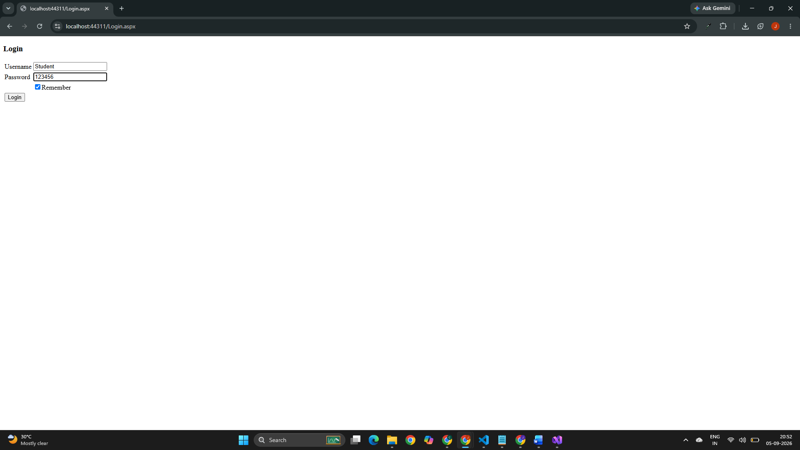
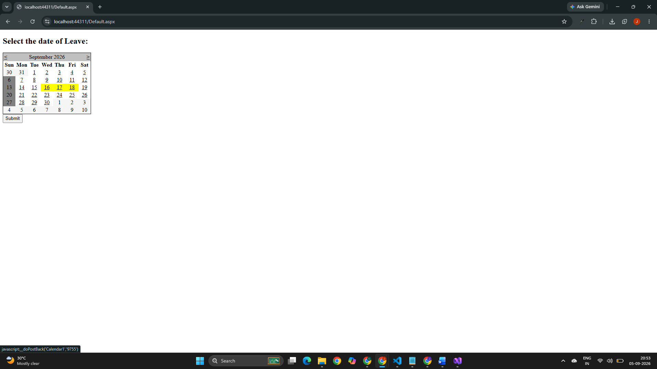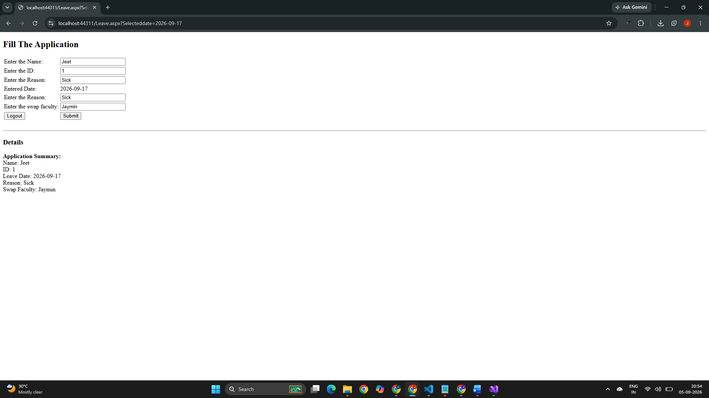
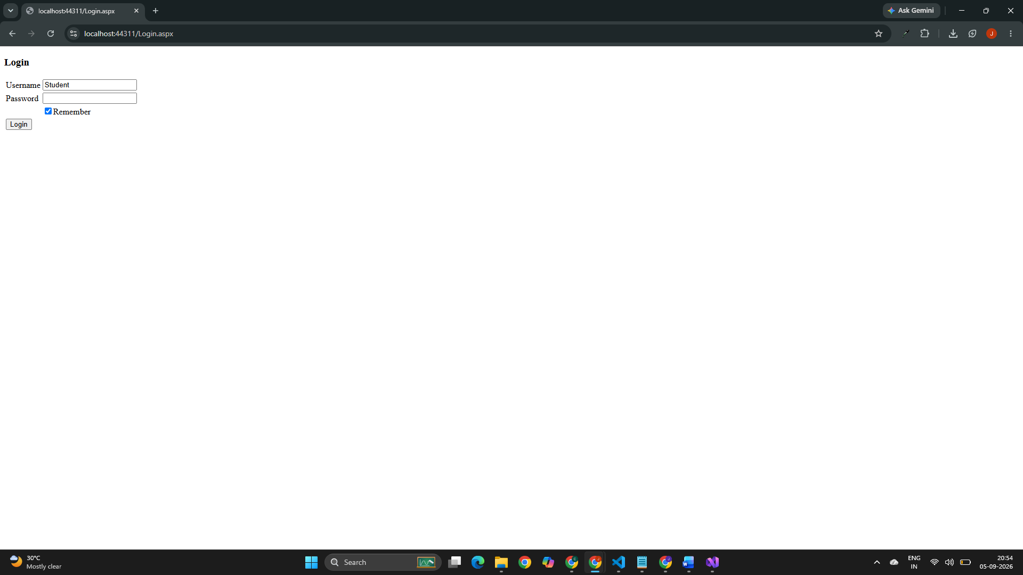

Github Url: https://github.com/jd-thakrar/Uni-DotNet-Work/tree/master/Practical-5/Practical-5

